**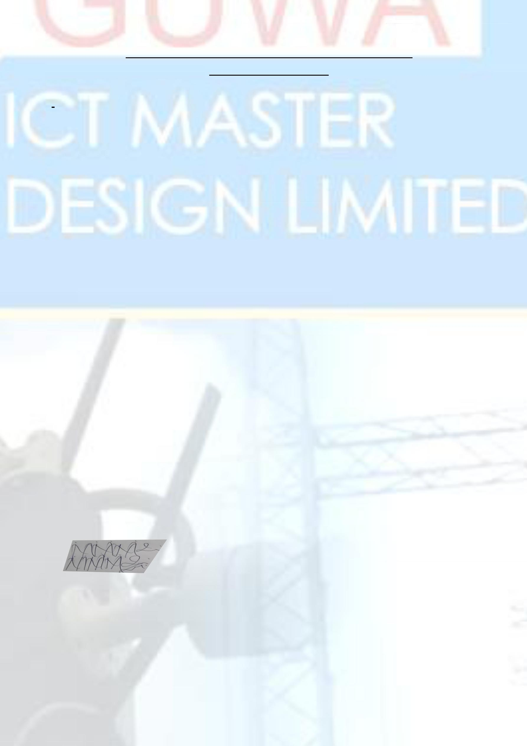****OGUWA CEO ADDRESS**

We hereby introduce to you our company OGUWA ICT MASTER DESIGN LIMITED, an Information Technology firm also specialty in Centralized CCTV Installation/Maintenance, Safety Gadgets Installation, Internet Service provider Indoor/Outdoor Wi-Fi, Installation of Satellite and design development, Water hosiery Installation, Telecommunication Installation, Computer Engineering and remote view host management. OGUWA ICT MASTER is duly incorporated in Nigeria with her head office in Lagos.

We have the capacity to handling multi-complex projects such as CCTV Monitoring System installation, Safety gadgets and Remote access Satellite Installation and general Advance new model interactive devices around the world, given our position and focused on technical and centralize projects remote management team.

May we state that we strive as an independent project management policy which guarantees an on –the-spot decision making (quick decision ) on project needs, therefore reducing delay tendencies on projects real time. This implies that we lay emphasis on the need to deliver clients projects a high quality and on time.

We also us the opportunity to empower the church youths in term of training for the duration of one year on deferent area of Information Technology such as;

* Installation of Centralized IP cameras (CCTV) and how to view it in any other country you are through your mobile App with good Notification Safety Detection
* Installation of IP phones and internal Telecommunication system hybrid
* Interlink of all Satellites and signal transmissions Outdoor and Indoor hybrid
* Safety Gadgets and water sensor Detection
* Internet Service provider Outdoor and Indoor Hotspot

However, we would be very delighted if we could be considered for a brief meeting in your organization and any kind, to sell our products in stock to you that we considered experience of Information management on CCTV installation and any others I.T jobs etc.

Yours faithfully,

For: Oguwa ICT Master Design Limited

**Engr. Samuel Sule**

**MD/CEO**

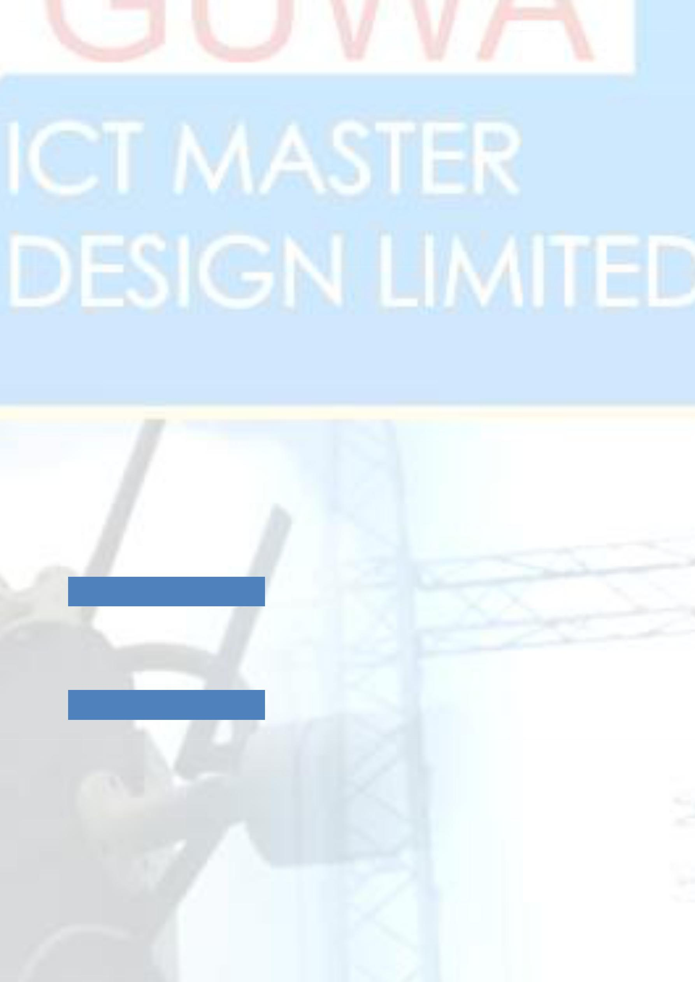**COMPANY BACKGROUND**

Formed in some years by a team of leading senior executives of the Telecoms and IT industry, OGUWA ICT MASTER DESIGN LIMITED started as level on enterprises before upgraded to limited is able to provide the most detailed and broadest strategic view of the industry landscape, its players and the overall market opportunity. Additionally, we maintain a broad network of subject matter experts available to provide direct engagement and scaling of your teams at critical times.

We have years of experience in helping organizations to achieve their business objectives, together with extensive consulting experience. We fully understand the unique challenges that you face and can tailor solutions for your specific requirements.

OGUWA ICT MASTER DESIGN LIMITED, is a professional services organization registered in Nigeria, provides a full range of professional services, business solutions and products.

Over the past 7 years, OGUWA ICT MASTER DESIGN LIMITED has grown rapidly and is developing into a world-class business, with excellent capabilities in delivering integrated solutions management and technology consultancy in the converging markets of Information Technology through our team of professionals and through strategic partnerships with businesses that are leaders in their areas of focus. A compelling mission and vision continually drive us.

**VISION**

“We strive to always be a **financially strong** company representing excellence, securing **continuous growth** for our customers, employees and shareholders.”

**MISSION STATEMENT**

We help our customers optimize their businesses through leadership and innovation delivering appropriate technological solutions on time and on budget, whilst recruiting and retaining the best talent.

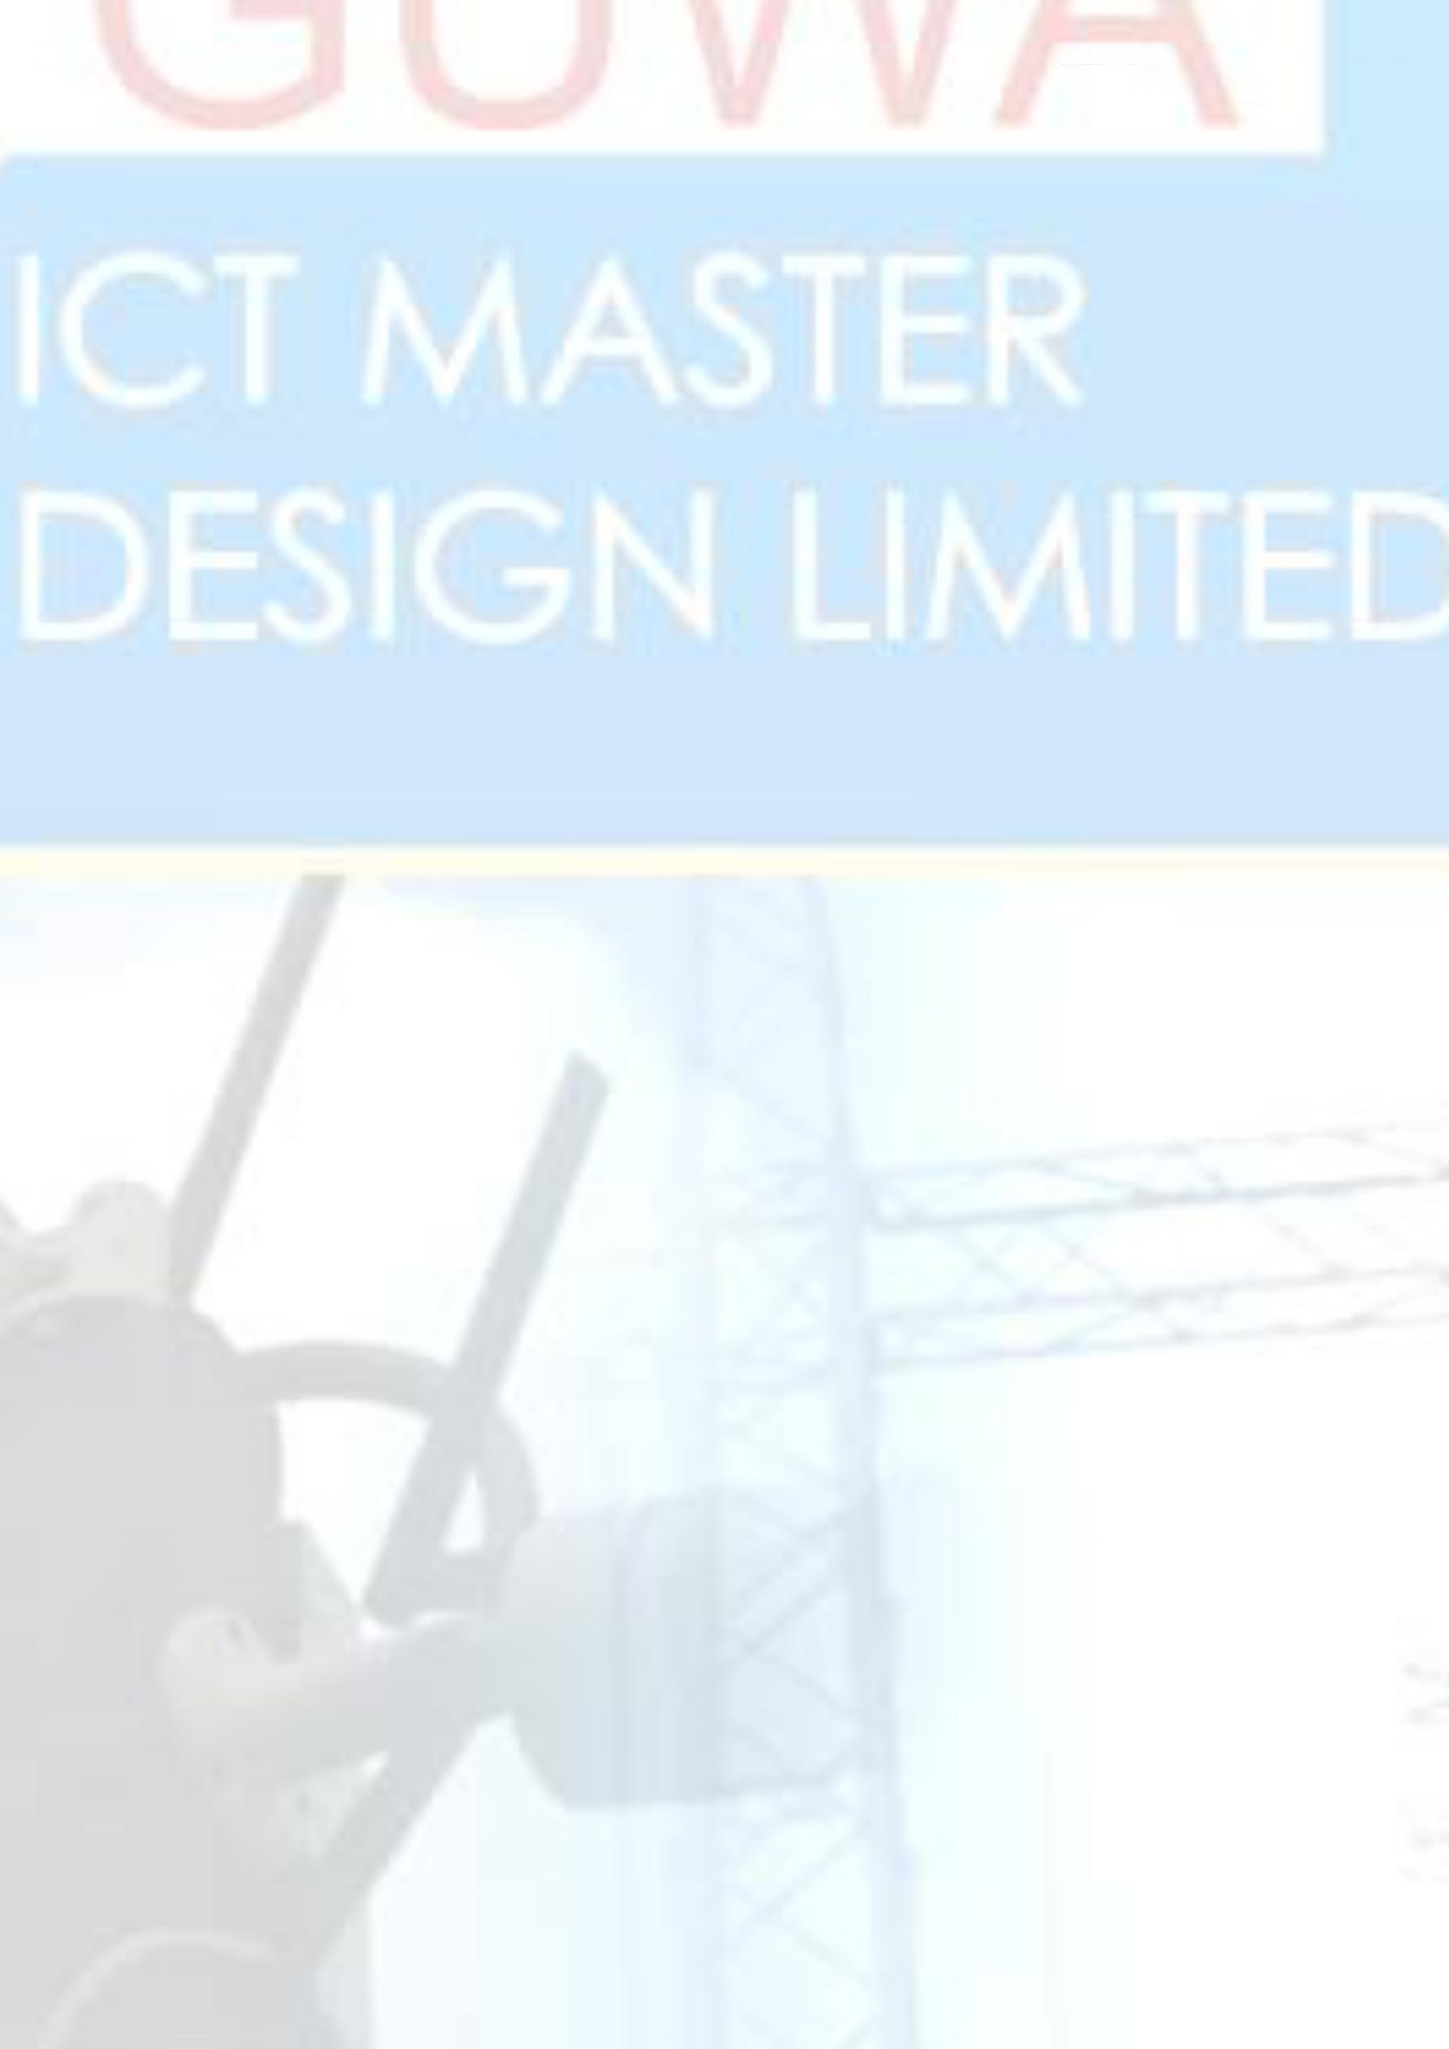**CORE VALUES**

Our core values are driven by the underpinning responsibility to our:

**Shareholders:** We consider ourselves successful only when we present financial results thatdeliver a return that is superior to our leading competitors.

**Customers:** We develop partnerships with our customers. We provide them with innovativeleadership in solutions and services aimed at making them successful, on the basis of competitive price, quality and reliability.

**Employees:** We regard our employees as our most valuable asset. We treat them withrespect; encourage self-expression, personal freedom and growth. Excellence in performance is sought and rewarded.

**Society:** We recognize that we are citizens within a society. We strive to be sensitive tosocial concerns, the community, the environment, and the various economic systems in which we conduct our business. We aim to be a positive contributor to Nigeria, the continent and the world as a whole. **KEY FOCUS AREAS/ COMPETENCIES**

Our range of solutions that has been focused on Municipalities, Government Agencies and

Government Departments both at National, Provincial and Local level, and on the Private

Sector in the following areas:

Full Technology Service Offerings

We provide a full suite of professional technology services covering:

* ***Computer Engineering***
* ***CCTV & Remote Security Networking Engineering***
* ***Digital Electric Fence Defender Installation & Integration***
* ***Sensors & Safety Gadgets Detection Installation***
* ***Remote Telecommunication Installation & Integration Satellite Installation & Integration***
* ***Internet Installation***
* ***Access Point Wire/Wireless Radio & Others***
* ***Advance Digital Interactive Devices***
* ***Installations***
* ***Printers installations***
* 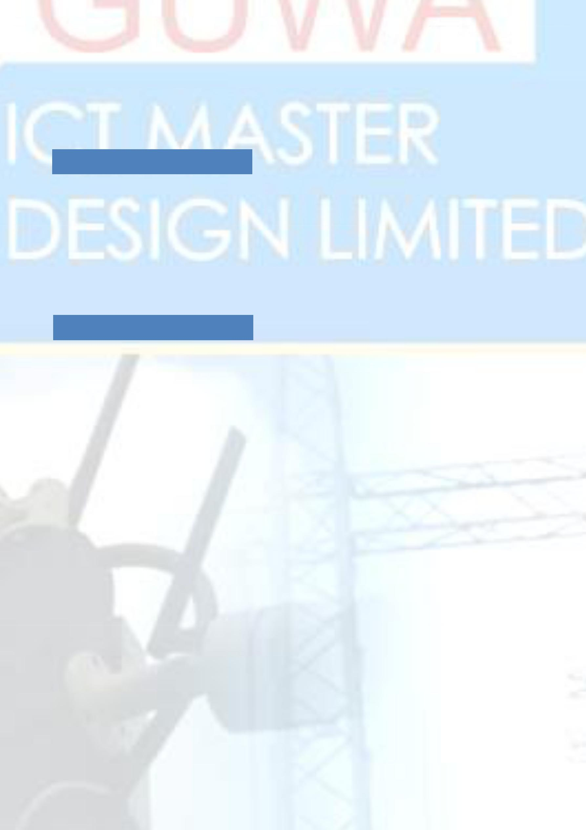***Troubleshooting***
* ***Networking and internet setup solutions***
* ***ICT consultancy and training***
* ***Hardware and software solutions***

**TELECOMMUNICATIONS:**

We offer your enterprise ways in which it can perform at its highest levels through value-creating communications. We assist businesses that have to work through constrained capital budgets, have disparate key systems at various branches that are experiencing significant growth or seasonality. We also offer solutions to organizations that are constrained through limited IT resources for implementation and management.

**FINANCIAL SOLUTIONS**

Our team of professional consultants specializes specifically in Business solutions. These applications address manufacturing, financial, human resources, customer relationship management, supply chain, and other business systems needs throughout the enterprise. We offer a complete range of implementation services - from system design to configuration, testing and deployment.

OGUWA ICT MASTER DESIGN LIMITED has positioned itself to be both an implementation partner and a long-term strategic partner for the delivery of full ongoing post-implementation support and other continuous improvement services where required by an organization. As a result we can provide our clients with a “one-stop-shop” for the full spectrum of possible services.

We pride ourselves in the depth and breadth of our professional services experience. We bring together systems implementation and business consulting - helping you capitalize on every opportunity to maximize value and reduce costs.

We have access to tools and templates developed by our own experienced consultants that can be used to achieve implementations faster with lower cost of ownership. These tools are scalable and can be customized to meet your specific needs